Nano pinout

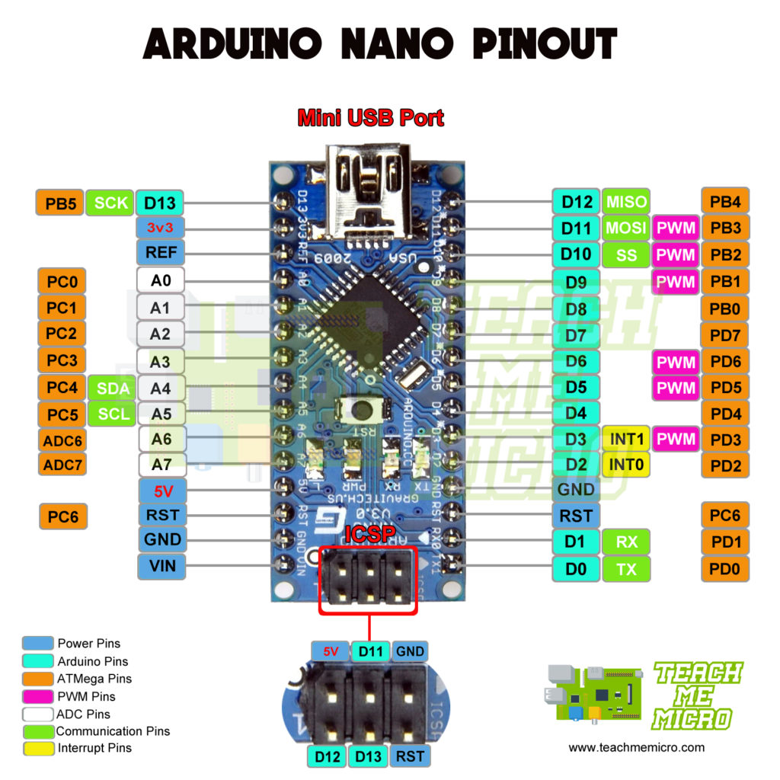

Oddajnik
Nrf24l01 pins:
VCC->3.3V
GND->GND
MOSI->D11
MISO->D12
SCK->D13
CSN->D10
CE->D9